Standard Operating Procedure (SOP) for Azure Alerts

Overview

This SOP outlines the process for monitoring and responding to Azure Alerts. The goal is to ensure that all critical alerts are addressed promptly to maintain system health and performance. To check the alerts in Azure Portal, log in to portal.azure.com.

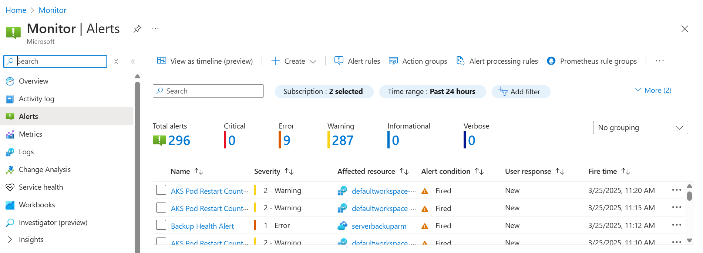

Types of Azure Alerts-

Metric-Based Alerts

Alert Name | Environment | Threshold | Email Sent To | Priority | Action
Prod Cluster Health less than 1 | Prod | 1 | helpdesk@cognitioanalytics.com | Critical | Need to report
Prod CPU Usage Percentage High | Prod | 30% | helpdesk@cognitioanalytics.com | Warning / Informational
Prod Inflight Request Maximum | Prod | 50 | helpdesk@cognitioanalytics.com | Warning / Informational
Prod Memory Working Set Percentage High | Prod | 60% | helpdesk@cognitioanalytics.com | Warning / Informational
Prod Network in Bytes | Prod | 1 Gb/sec | helpdesk@cognitioanalytics.com | Warning / Informational
Prod Network Out Bytes | Prod | 500 Mb/sec | helpdesk@cognitioanalytics.com | Warning / Informational
Prod Scale Down Cooldown | Prod | 10 | helpdesk@cognitioanalytics.com | Important | Need to report
Prod Statuses for Various Node Conditions | Prod | 5 incidents in 30 min | helpdesk@cognitioanalytics.com | Warning / Informational
Prod Resource Health Maximum | Prod | 90% | helpdesk@cognitioanalytics.com | Critical | Need to report

For Example-

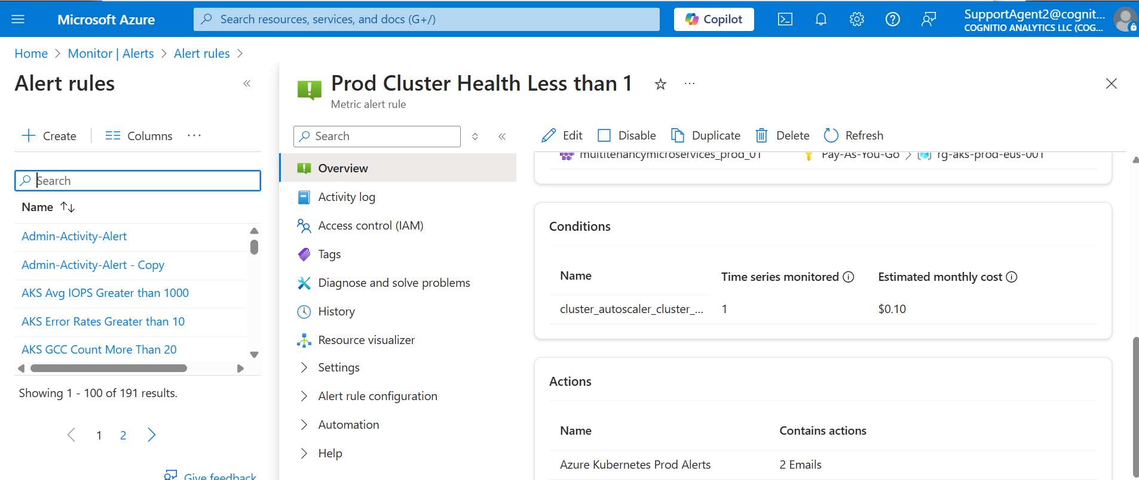

Resource-Based Alerts

Category | Environment | Threshold | Email Sent To | Priority | Action
Load Balancer Deleted - "kubernetesprod" | Prod | NA | helpdesk@cognitioanalytics.com | Critical | Need to report
Service Bus Deleted - "sbmultitenancyprod" | Prod | Every instance | helpdesk@cognitioanalytics.com | Critical | Need to report
Storage Account Availability < 100% - "stamultitenancyprod" | Prod | Less than 100% | helpdesk@cognitioanalytics.com | Warning / Informational | If once in a while, no problem; if continuous, report
Storage Account Latency > 100ms - "stamultitenancyprod" | Prod | 300ms | helpdesk@cognitioanalytics.com | Warning / Informational | If once in a while, no problem; if continuous, report
Transaction Errors Detected on Storage - "stamultitenancyprod" | Prod | 10 | helpdesk@cognitioanalytics.com | Warning / Informational | If once in a while, no problem; if continuous, report
Storage Account Deleted - "stamultitenancyprod" | Prod | Every instance | helpdesk@cognitioanalytics.com | Critical | Need to report
Azure Cache for Redis Deleted - "rcmultitenancyprod" | Prod | Every instance | helpdesk@cognitioanalytics.com | Critical | Need to report
Azure Container Registry Deleted - "craksprodeus" | Prod | Every instance | helpdesk@cognitioanalytics.com | Critical | Need to report
Key Vault Deleted - "kvmultiTenancyprod01" | Prod | Every instance | helpdesk@cognitioanalytics.com | Critical | Need to report

For Example-

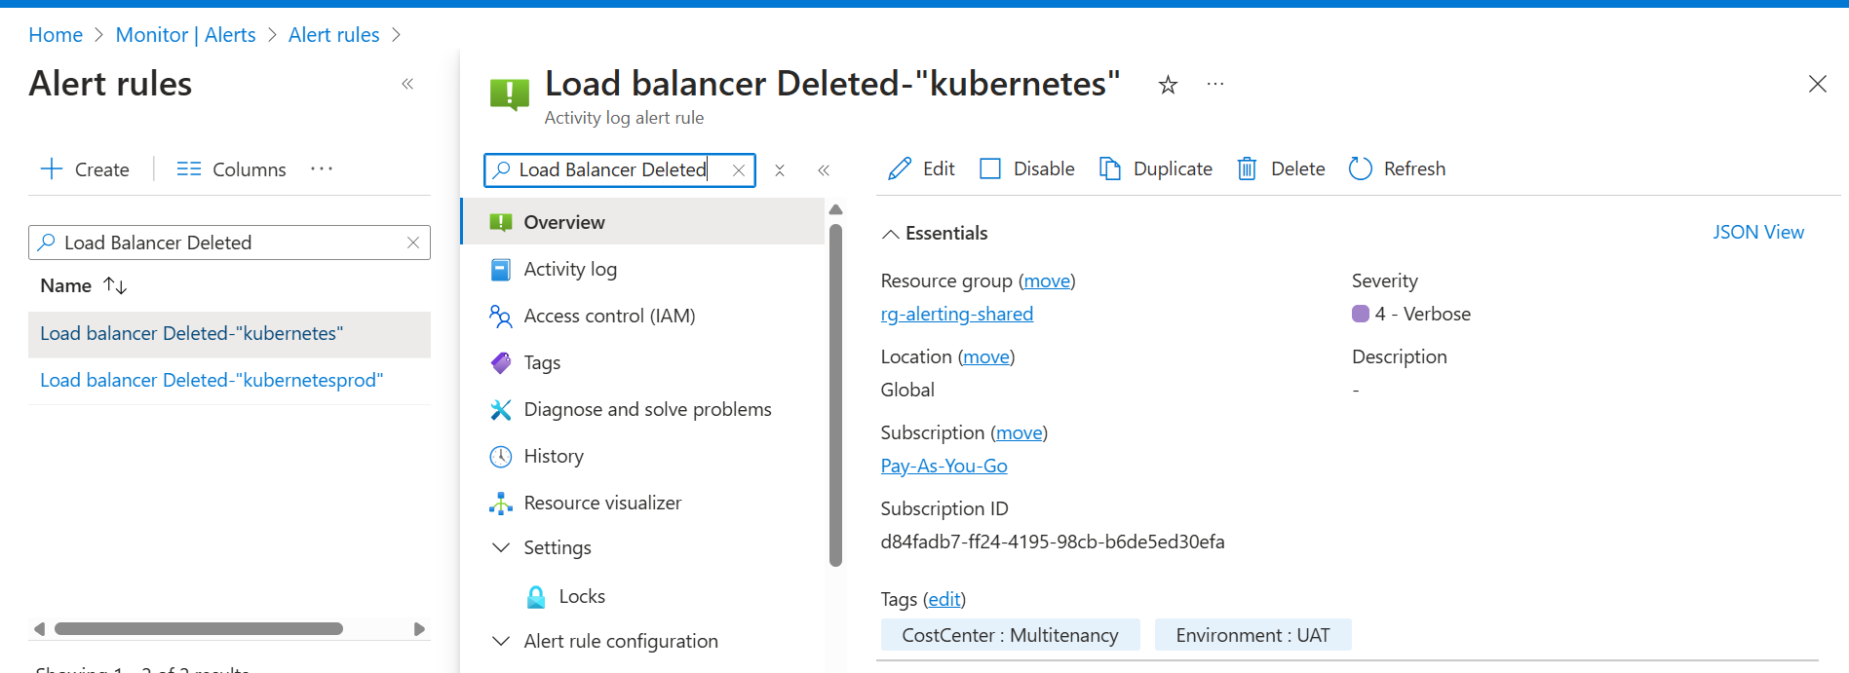

Critical Alert Handling

Critical alerts: Any alert related to prod_01 (e.g., multitenancymicroservices_prod_01) is treated as high priority and requires immediate action.

Example of an Alert Notification Email:

Field | Details
Alert Name | Prod Inflight Request Maximum
Severity | 3
Environment | Prod
Triggered At | March 19, 2025, 00:07 UTC
Alert Rule ID | /subscriptions/d84fadb7-ff24-4195-98cb-b6de5ed30efa/resourceGroups/rg-alerting-shared/providers/microsoft.insights/metricAlerts/Prod Inflight RequestMaximum
Resource ID | /subscriptions/d84fadb7-ff24-4195-98cb-b6de5ed30efa/resourceGroups/rg-aks-prod-eus-001/providers/Microsoft.ContainerService/managedClusters/multitenancymicroservices_prod_01
Metric Name | apiserver_current_inflight_requests
Metric Namespace | managedClusters/multitenancymicroservices_prod_01
Dimensions | ResourceId = /subscriptions/d84fadb7-ff24-4195-98cb-b6de5ed30efa/resourceGroups/rg-aks-prod-eus-001/providers/Microsoft.ContainerService/managedClusters/multitenancymicroservices_prod_01
Time Aggregation | Total
Period | Over the last 15 mins
Value | 347
Operator | GreaterThan
Threshold | 300
Criterion Type | StaticThresholdCriterion

Notification and Escalation Process:

Alerts are received via email and the ticketing system (ManageEngine Ticketing System).

Upon receiving an alert:
- Review the alert details to assess urgency.
- Inform the responsible person based on urgency.
- Take necessary action to mitigate the issue.
- Update the ticket with actions taken and resolution status.

Filtering Alerts in Ticketing System:

Filters can be configured in the ticketing tool to ensure that no important alerts are missed.

